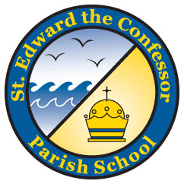
St. Edward the Confessor Parish School
A National Blue Ribbon School Accredited by WCEA & WASC

CHORISTERS

The Middle School Choir, “Choristers,” grades 6-8, will rehearse on Tuesdays immediately after school from 3:00-3:40 upstairs in the school Parish Room. Rehearsals for the Choristers begin Tuesday, September 13th. There is no fee for the Choristers Choir. The St. Edward athletic coaches have given the Choristers permission to arrive a little late to after-school sports programs without adverse consequences.

CHORISTERS PERMISSION SLIP

My child ______________________________ Grade ____
Please print child’s first and last name
has my permission to join the Choristers Tuesdays after school from 3:00 – 3:40 in the church.

___________________________________
Please print parent’s first and last name

___________________________________Date_________
Parent’s signature

Home Phone ______________ Cell Phone_____________
Business Phone ___________________
Email address ____________________________________
Please print legibly

Please turn in this permission slip to my box in the School office or have your Chorister bring it to the first practice.

